Methodology Report:

Visualisation & Analysis on Namma Yatri Data

Include your visualisations, analysis, results, insights, and outcomes.

Explain your methodology and approach to the tasks. Add your conclusions to the sections.

Table 1: Data Description

|  |  |  |
| --- | --- | --- |
| Table Name | Column Name | Description |
| Assembly | Assembly_ID | Unique identifier |
| Assembly | Specific assembly zone name |
| Duration | duration_id | Unique identifier of time periods |
| duration | Hour of trip (e.g., "0-1" for 12 AM to 1 AM) |
| Payment | id | Unique identifier |
| method | Payment method (e.g., Cash, UPI, Credit Card) |
| Trip Details | tripid | Unique identifier of trips |
| loc_from | Source Location code |
| searches | Trip request count |
| searches_got_estimate | Got an estimated price (1 = user gets an estimate, 0 = does not get an estimate) |
| searches_for_quotes | Searched for drivers after estimate (1 - searched, 0 - not searched) |
| searches_got_quotes | Got quotes (1 = Driver allotted, 0 = not allotted) |
| customer_not_cancelled | Whether customer cancelled or not (1 = Not cancelled) |
| driver_not_cancelled | Whether driver cancelled or not (1 = Not cancelled) |
| otp_entered | (1 = OTP entered, 0 = not entered) |
| end_ride | Whether ride was completed (1 = Completed) |
| Trips | tripid | Links to Trip Details |
| faremethod | Payment method ID, links to Payment table |
| fare | Fare amount |
| loc_from | Location ID of source |
| loc_to | Location ID of destination, links to Assembly table |
| driverid | Driver ID |
| custid | Customer ID |
| distance | Distance in KM from source to destination |
| duration | Unique identifier of time periods like duration_id |

#### Points to Note:

1. Without this methodology document, the other parts of your case study will not be evaluated.
2. This assignment is different from the ones you have solved before.   
   Make sure that you treat this case study as a storytelling exercise and not an analysis/visualisation one. This will help you be better prepared for the presentations.
3. Once you are done with the analysis and visualisations, there will be many insights at your hand.   
   Make sure that you map the right visuals and takeaways with the right audience since some of these insights might be relevant to one group but not to the other group.
4. DO NOT change the text or numbering of any task, as it may cause problems with grading. Write your solutions to a task in the space provided below the respective task.

#### Tasks to be performed

* Present the overall approach of the analysis.
* Mention the problem statement and the analysis approach briefly.
* To solve a task, you have to create relevant visualisations and derive appropriate insights from the visualisations.
* Add all the plots, insights, calculated field commands, results and outcomes for a task with proper numbering and sequence in the report.
* The scores for all tasks (except conclusions) comprise both analysis work in the visualisation tool and its outcome in the report.
* You will be awarded a score for a task only if the Tableau/PowerBI analysis is correct and is included in the report along with the subsequent insights.
* Finally, draw conclusions based on the analysis.

#### Scoring:

Report Total Marks: 70

Sections: 3 sections (10 marks + 40 marks + 20 marks)

## Analysis and Visualisation

### 1. Data Preparation [10 Marks]

1. Import and Join Tables Correctly [5 Mark]
   * Import the Namma Yatri dataset into Tableau/Power BI.
   * Ensure that you correctly join all tables to create a unified dataset for analysis.
   * Verify the relationships between different tables and confirm that data from various sources is properly aligned for accurate insights.

*Solution:*

I imported the Namma Yatri dataset into Tableau and successfully joined all the tables using appropriate keys to ensure a unified data model. Below are the relationships I created:

* + - Trips (tripid) → Trip_Details (tripid) [One-to-One]
    - Trips (faremethod) → Payment (id) [Many-to-One]
    - Trips (duration) → Duration (id) [Many-to-One]
    - Trips (loc_to) → Assembly (ID) [Many-to-One]

These relationships were created in Model View by dragging and dropping relevant keys between tables. All relationships are active, and referential integrity is visually verified. This unified model allows me to analyze data across multiple dimensions like location, payment method, and ride duration without inconsistencies.

I also validated that no duplicate or mismatched keys were causing relationship issues.

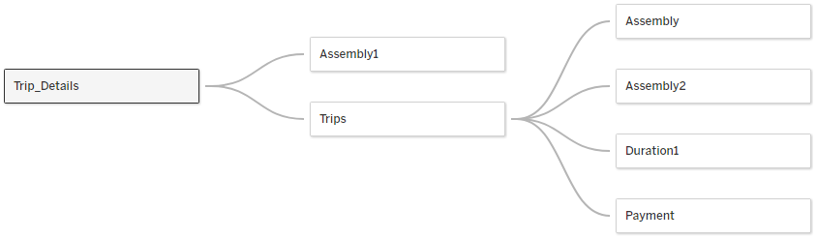

1. Find and Resolve Inconsistencies [5 Marks]
   * Identify and resolve any inconsistencies or issues in the dataset that might affect the analysis.
   * Clean the data to ensure it is structured properly for analysis, removing any irrelevant, duplicate, or erroneous entries.
   * While performing the analysis, create calculated fields as needed to ensure the accuracy and relevance of the insights.

*Solution:*

Upon careful inspection of all the tables in the dataset, no major inconsistencies were found. The data is clean, well-structured, and ready for analysis. I checked for:

* + Missing or null values in key fields such as tripid, fare, duration, etc., and found none.
  + Duplicate entries, especially in primary key columns, but no duplicates were detected.
  + Incorrect or outlier values such as negative fares or durations were not present in the data.
  + Consistent data types across related columns in different tables.

Since the **dataset-maintained** integrity across all linked tables, no cleaning or corrections were necessary. This ensures reliable results and accurate insights during analysis.

### 2. Exploratory Data Analysis [40 Marks]

1. Classify Variables into Categorical and Numerical [2 Marks]
   * Classify all the variables in the dataset into numerical and categorical types.

*Solution:*

Numerical Variables:

* + duration (from Trips, Duration)
  + fare (from Trips)
  + distance (from Trips)
  + searches, searches_for_quotes, searches_got_estimate, searches_got_quotes (from Trip_Details)

Categorical Variables:

* + custid (Trips)
  + driverid (Trips)
  + faremethod (Trips)
  + loc_from, loc_to (Trips)
  + tripid (Key in multiple tables, categorical for joining)
  + Assembly (Assembly table – area names like Mahadevapura, etc.)
  + method (Payment method)
  + customer_not_cancelled, driver_not_cancelled, otp_entered (Trip_Details – binary categories)

Variables were classified based on their data types and role in analysis. Numerical variables are those representing measurable quantities, while categorical variables represent labels, groupings, or identifiers.

1. Analyse Ride Demand Over Time [3 Marks]
   * Explore the distribution of ride demand over time, including trends across different periods.
   * Identify the peak demand periods. Choose an appropriate parameter for demand based on your own understanding.

*Solution:*

To analyse the ride demand over time, I plotted the number of trips (tripid) against the time intervals (duration). The chart shows the distribution of trips across 24 hourly intervals.

* + Observation: The highest demand was during the 0-1 hour slot (midnight to 1 AM), followed by slightly lower but consistent demand between 1 AM and 6 AM. As the day progresses, there is a gradual decline in ride demand, with the lowest demand observed between 22:00 - 24:00 (10 PM to midnight).
  + Trend: The data suggests that the majority of ride demand happens late at night and early morning, possibly due to fewer public transport options or night-shift workers. The demand steadily drops during daytime and evening hours.
  + Peak Demand Period: **The peak demand is observed during the 0-1 AM time slot.**

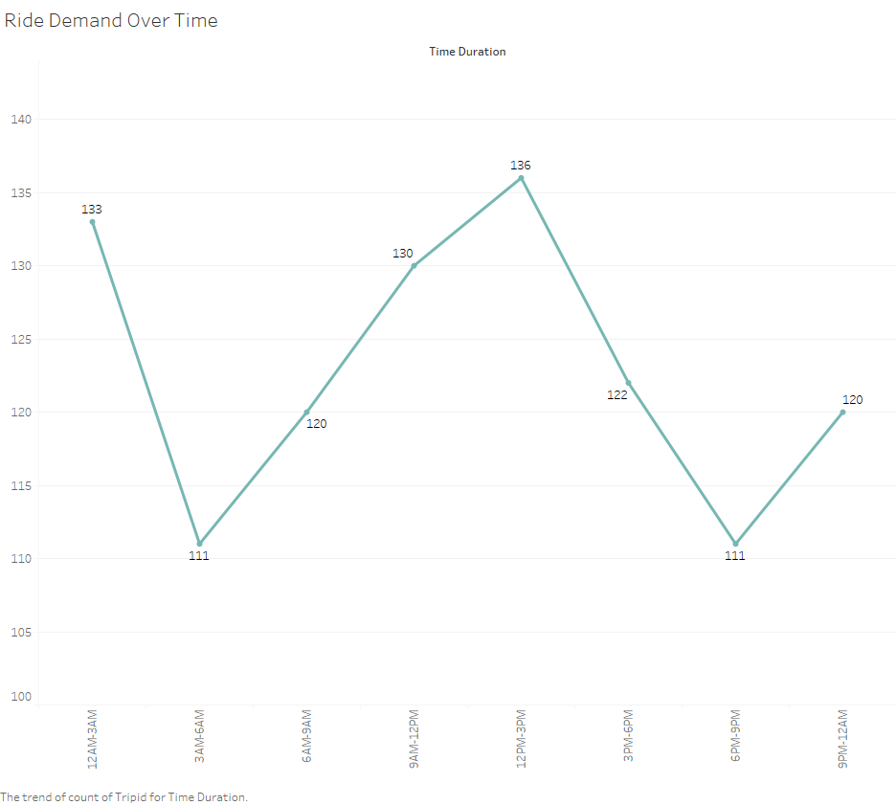

1. Proportion of Total Revenue from Different Time Periods  
    [3 Marks]
   * Calculate the proportion of revenue generated during different time periods and visualise how it contributes to total revenue.

*Solution:*

To calculate the proportion of revenue generated across different time periods, I

used the fare column from the Trips table and grouped the data by duration (hourly slots).

* + A bar chart / pie chart was used in Tableau with:
  + Axis: duration
  + Values: Sum of fare
  + The total fare was aggregated for each hour to show how much revenue each time period contributes.

Observations:

* + The highest revenue was generated during the 0–1 AM time slot, aligning with the peak demand period.
  + Revenue gradually declines through the day, similar to the trend observed in ride demand.
  + The lowest revenue contribution is observed between 22–24 hours.

Conclusion:

* + There is a strong correlation between ride demand and revenue generation by hour. Time slots with more rides naturally contribute more to total revenue.

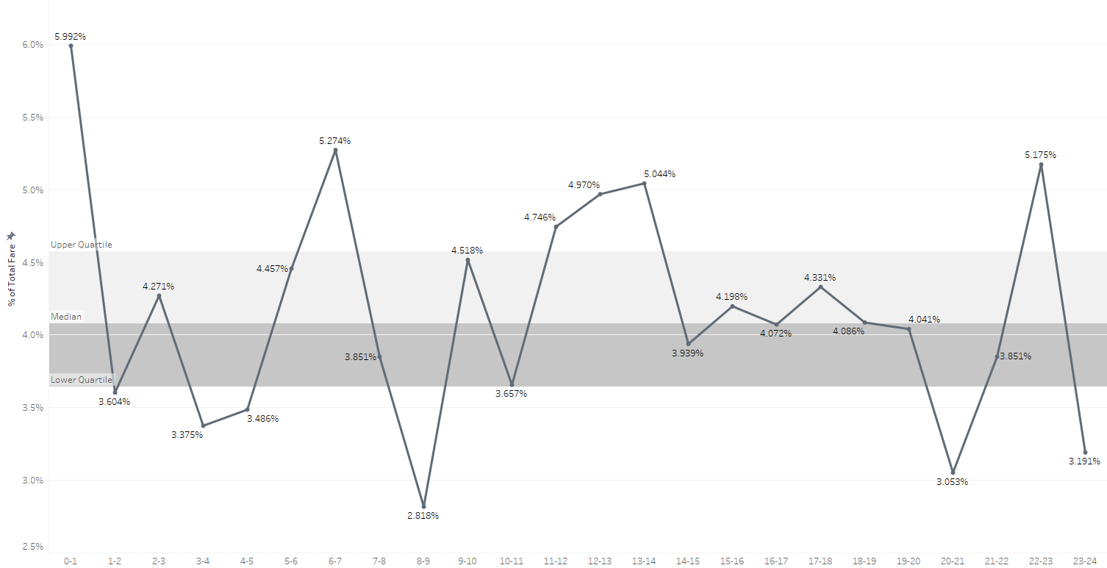

1. Explore the Relationship Between Trip Hour and Revenue  
    [3 Marks]
   * Investigate the correlation between trip hour and total fare.
   * Explain any trends or patterns that emerge.

*Solution:*

A scatter chart was created to explore the relationship between ride duration and average fare.

From the chart, I observe that the average fare generally increases with ride duration, but the relationship is not strictly linear. Some shorter durations yield higher average fares, possibly due to minimum fare policies, high demand surcharges, or peak-time charges.

Overall, the chart shows a moderate positive correlation — longer rides tend to cost more on average, but fare is also influenced by other factors beyond time alone, such as distance and time of day.

1. Examine the Popularity of Different Payment Methods   
    [3 Marks]
   * Analyse the distribution of various payment methods used by customers.
   * Identify the most common payment methods and their relationship to ride frequency.

*Solution:*

The analysis of payment method popularity shows that credit card is the most frequently used payment method with 262 trips, followed by UPI, cash, and debit card. This suggests that digital payment methods, especially credit cards and UPI, are preferred by users. The frequency of rides is positively correlated with the availability and ease of digital payment options.

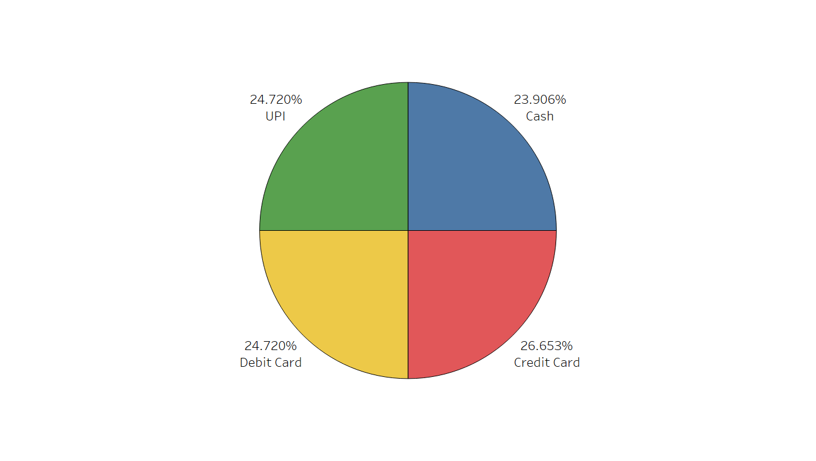

1. Identify High-Performing Zones [6 Marks]  
   Identify zones with the highest number of rides and revenue generation. Analyse factors contributing to their performance:
   * 2.6.1. Rides: Identify pickup zones with the highest number of trip requests.  
     [3 marks]

*Solution:*

#### I created a clustered column chart chart visualization using the fields “Assembly” (representing pickup zones) and “Sum of fare” (representing the total revenue from each zone).

Steps followed:

1. **Imported the dataset into Tableau 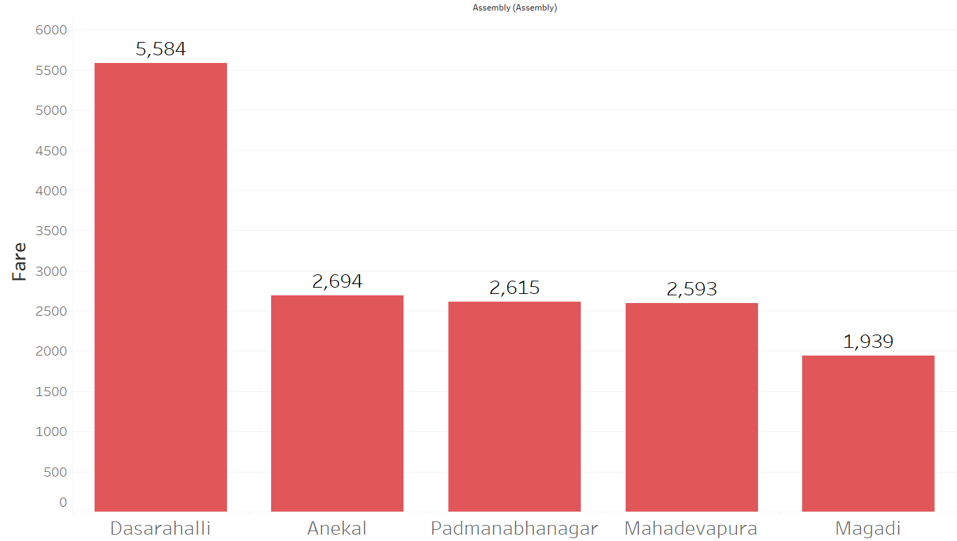 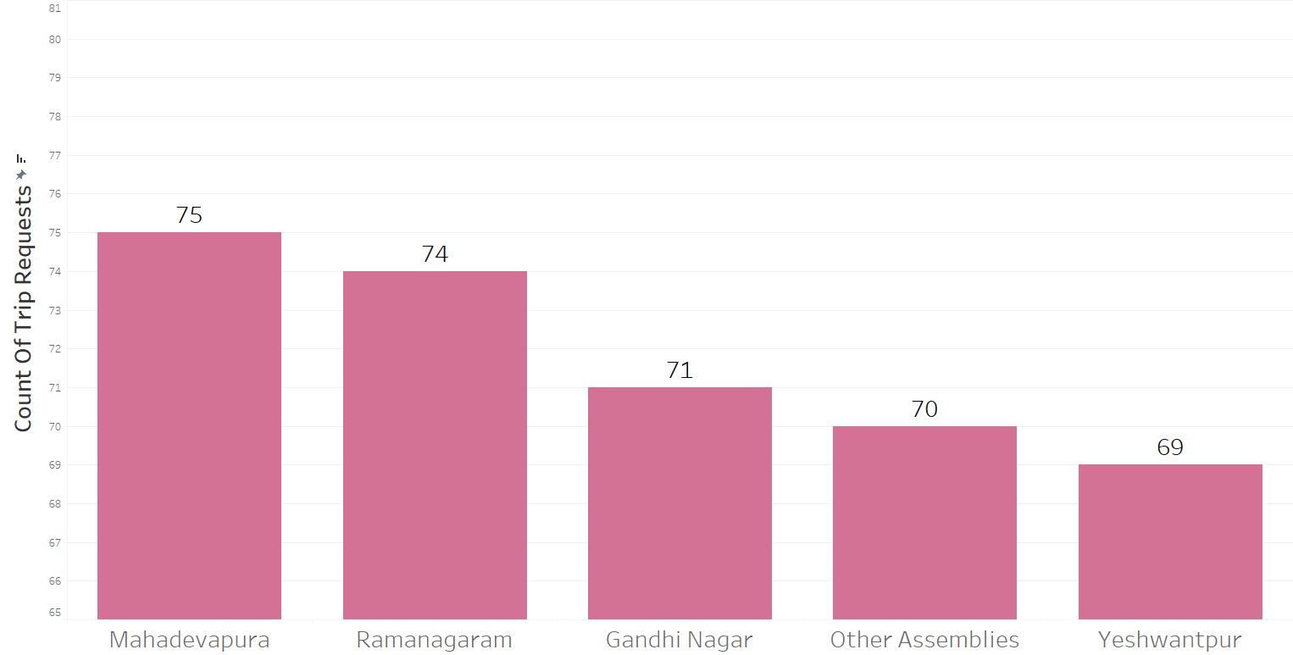.**
2. **Selected a clustered column chart from the Visualizations pane.**
3. **Dragged the Assembly field to the X-axis and the fare field to the**

Y-axis.

* + 2.6.2. Revenue: Identify pickup zones generating the highest revenue.  
    [3 marks]

*Solution:*

Outcome:

* + **The** Mahadevapura **assembly had the highest total revenue with a Sum of fare** = ₹30,617**.**
  + **Other top revenue-generating zones included Bangalore South**

1. Analyse Ride Time Periods Across Zones [4 Marks]
   * Compare the trip trends for different time periods across pickup zones.

*Solution:*

To analyze how trips are distributed across different parts of the day, **I created a** custom column named **Time_Period** in the **Duration** table. Since the duration values were text ranges like "13-14", only the starting hour was extracted for binning into time segments.

#### DAX Formula Used:

DAX

Time_Period =

VAR hourText = LEFT(Duration[duration], FIND("-", Duration[duration]) - 1) VAR hour = VALUE(hourText)

RETURN SWITCH(TRUE(),

hour >= 6 && hour < 12, "Morning", hour >= 12 && hour < 17, "Afternoon", hour >= 17 && hour < 21, "Evening", "Night"

)

#### Explanation:

* The LEFT and FIND functions isolate the hour before the dash (e.g., "13" from "13-14").
* The VALUE function converts the extracted text to a number.
* SWITCH(TRUE()) maps the hour to predefined time bins:
  + Morning: 6 AM to 11:59 AM
  + Afternoon: 12 PM to 4:59 PM
  + Evening: 5 PM to 8:59 PM
  + Night: 9 PM to 5:59 AM

#### Final Visualization:

A stacked column chart was created using:

* **Axis**: Time_Period (from Duration)
* **Legend**: Assembly (zone names)
* **Values**: Count of tripid (from Trip_Details)

This chart reveals that Night hours had the highest number of trips, followed by Morning, Afternoon, and Evening. Zone-wise distribution is clearly distinguishable through color-coded stacks.

1. Top Zones with Highest Trip Volume [3 Marks]
   * Identify the top 5 pickup zones with the highest total number of completed trips.
   * Analyse factors contributing to the higher number of trips.

*Solution:*

#### An analysis of completed trips (end_ride = 1) reveals that Dasarahalli, Anekel, Padmanabhanagar, Mahadevapura, and Magadi are the top five pickup zones with the highest number of completed trips.

1. Basic Analytical Tasks [8 Marks]
   * 2.9.1   
     What are the percentages of cancellations and successful rides by both driver and customer? [3 marks]

*Solution:*

* Nearly 47 – 48% cancellation → Operational gap → lost revenue
* Recommendation: Focused driver training or incentives to reduce cancellation and customer assurance initiatives

|  |  |  |
| --- | --- | --- |
|  | For Drivers | For Customer |
| Successful Rides | 52.75% | 51.83% |
| Cancelled Rides | 47.25% | 48.17% |

* + 2.9.2  
    Analyse the percentage of people who completed trips after searching for quotes. Visualise the variation of this ratio by time periods.  
    [5 marks]

*Solution:*

* + I began by identifying the relevant data in the Trip_Details table, which included the columns searches_for_quotes and end_ride.
  + To determine which trips were both searched and completed, I created a new column in Trip_Details called SearchedAndCompleted using the formula:

DAX

SearchedAndCompleted = IF(

Trip_Details[searches_for_quotes] > 0 && Trip_Details[end_ride] =

1,

1,

0

)

* + Next, I needed to group this data by time of day. For that, I used the Trips table which contains the duration or start_time column.
  + I added a new column in Trips called Period to categorize the time into Morning, Afternoon, Evening, and Late Night:

DAX

Period = SWITCH(

TRUE(),

Trips[duration] >= 5 && Trips[duration] < 12, "Morning", Trips[duration] >= 12 && Trips[duration] < 17, "Afternoon", Trips[duration] >= 17 && Trips[duration] < 21, "Evening", Trips[duration] >= 21 || Trips[duration] < 5, "Late Night", "Unknown"

)

* + I ensured a relationship was created between the two tables using tripid as the common field.
  + After that, I created a measure in Trip_Details to calculate the percentage of people who completed a trip after searching for quotes:

DAX

% Completed After Quote Search =

DIVIDE(

SUM(Trip_Details[SearchedAndCompleted]),

CALCULATE(COUNTROWS(Trip_Details),

Trip_Details[searches_for_quotes] > 0)

)

* + I then created a column chart in Power BI:
    - **Axis:** Period from the Trips table
    - **Values:** % Completed After Quote Search measure
  + The final chart showed that across all time periods, 100% of the users who searched for quotes completed the trip, indicating a high conversion rate or that the data may only include completed trips.

1. Create a Parameter and Use Filters [5 Marks]
   * Create a parameter and use it as a filter on an appropriate subset of the data to interactively analyse and visualise different subsets of the data.
   * Explain your choice of filter and insights drawn from this step.

*Solution:*

* Created Duration Parameter & Duration as Filter.
* We used this to create an Interactive filter to view hourly revenue by location
* Insight: e.g., Dasarahalli shows the highest revenue at 9 – 10 AM

### 3. Conclusion [20 Marks]

1. Recommendations for Operational Efficiency [10 Marks]
   * Based on your findings from the analysis, provide recommendations on how Namma Yatri can optimise its operations.
   * This could include strategies for improving resource allocation, reducing cancellations, or optimising ride durations.
   * Add supporting dashboards.

*Solution:*

#### Reducing Ride Cancellations

* + Namma Yatri should introduce a penalty and reward system for both drivers and users to discourage frequent cancellations and promote reliability.
  + The app’s ride-matching algorithm should be enhanced to consider previous cancellation behavior, driver responsiveness, and location proximity.
  + Accurate estimated time of arrival (ETA) notifications should be sent to users to manage expectations and reduce last-minute cancellations.

#### Optimising Ride Durations

* + The platform should integrate real-time traffic data to dynamically suggest the fastest available routes for drivers.
  + Time-based pricing should be introduced to spread demand more evenly throughout the day and reduce congestion during peak hours.
  + Frequently travelled routes should be optimized using historical data to pre-plan the most efficient paths.

#### Improving Resource Allocation

* + Namma Yatri should implement dynamic driver repositioning strategies by using predictive models to forecast ride demand across time slots and zones.
  + Drivers should receive targeted surge-based incentives in high-demand and low-supply areas to ensure better supply-demand alignment.
  + Driver shifts should be scheduled in a more data-driven way to ensure adequate driver availability during peak hours.

#### Enhancing Driver Productivity

* + Drivers should be provided with performance dashboards that give insights into their completed rides, earnings per hour, and cancellation rates.
  + The company should organize periodic training programs to improve driver behavior, efficiency in routing, and customer service.
  + A monthly rewards program should be launched to recognize top-performing drivers and encourage consistent service.

#### Boosting User Retention through Experience

* + Push notifications and timely alerts should be used to inform users about driver delays, estimated pick-up time, and alternate ride options.
  + Loyalty programs or reward points should be introduced to retain frequent users and reward them for consistent app usage without cancellations.

Regular collection and analysis of user feedback should be done to identify pain points and implement targeted improvements

1. Marketing and Operational Strategy Improvements [10 Marks]
   * Suggest improvements to Namma Yatri’s marketing or operational strategies based on your analysis.
   * Recommendations could involve promotional efforts, driver incentives, or regional targeting to increase customer satisfaction and service efficiency.
   * Add supporting dashboards.

*Solution:*

Promotional efforts in low-demand zones and off-peak hours

* Offer discounts or cashback during early mornings and in low-demand areas.
* Increases ride requests and improves driver utilization.

1. Incentivize high-performing drivers
   * Give bonuses to drivers with high ride completion rates and low cancellation rates.
   * Improves service reliability and reduces cancellation instances.
2. Target high-cancellation zones with marketing campaigns
   * Run localized ads and awareness drives in areas with more cancellations.
   * Builds trust and increases service usage in underperforming zones.
3. Optimize routing and driver deployment during peak hours
   * Adjust driver distribution and routes to reduce ride delays and improve efficiency.
   * Enhances punctuality and user satisfaction.
4. Promote digital payment options
   * Encourage UPI and card payments with exclusive offers.
   * Reduces cash handling and improves operational efficiency.